מטלה במערכות הפעלה

שאלה 1

ללא Debug info:

Division By Zero:

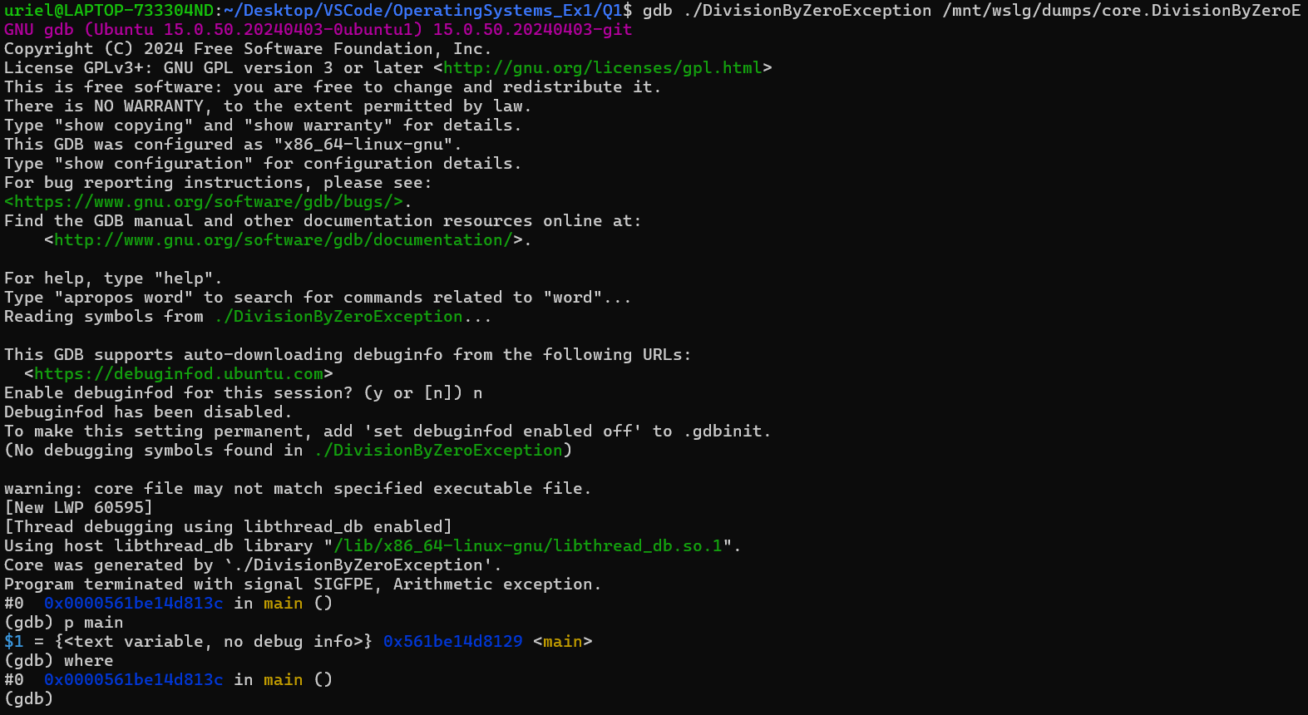

Stack Overflow Exception:

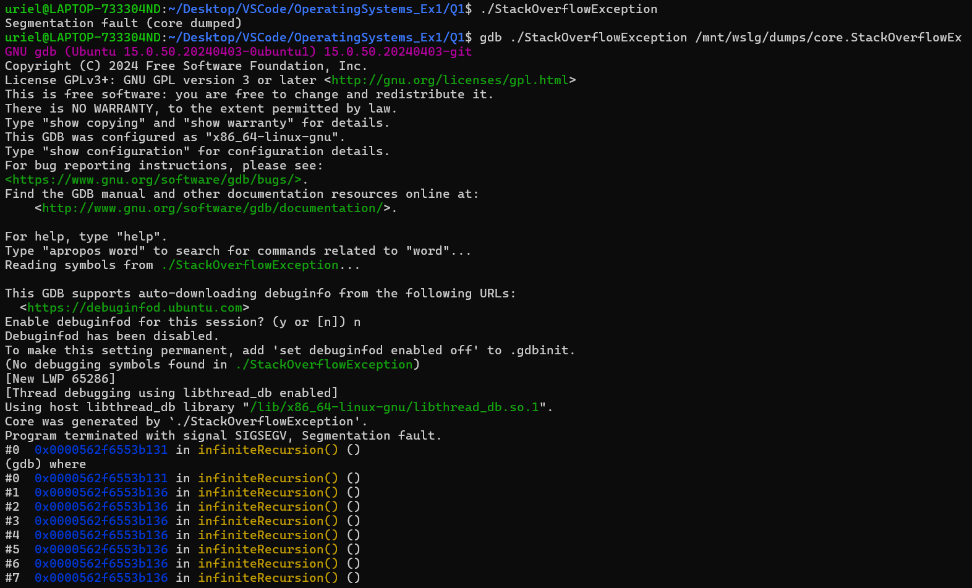

Undefined Memory:

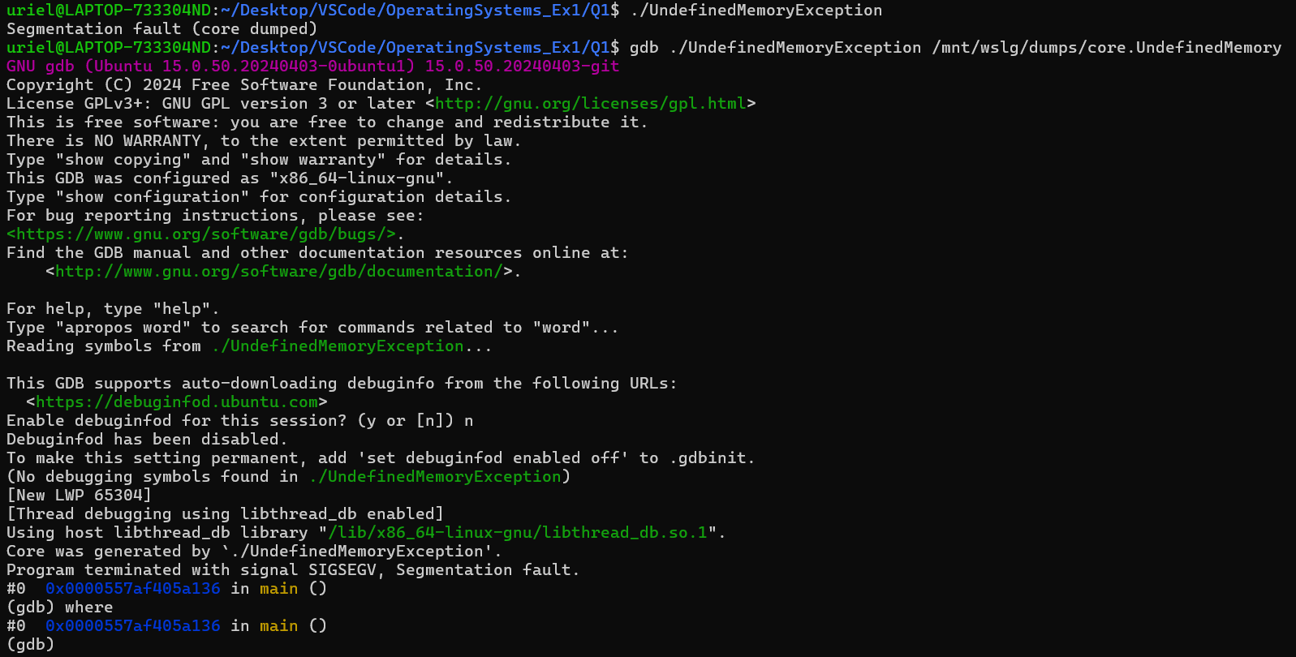

עם Debug Information:

Division By Zero:

Stack Overflow:

Undefined Memory:

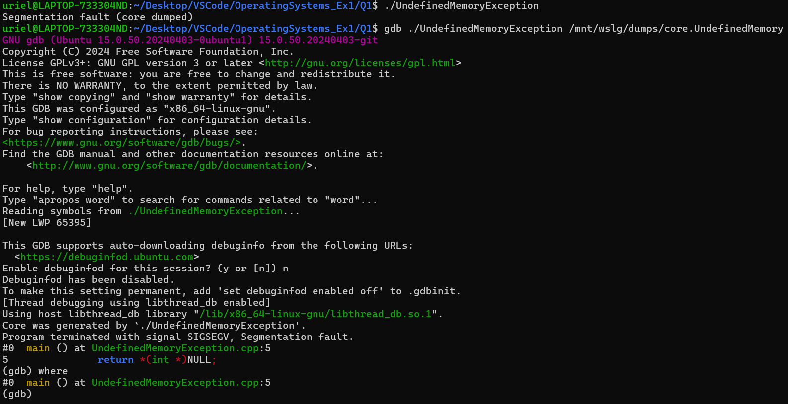

הרצה באמצעות DDD:

Division By Zero:

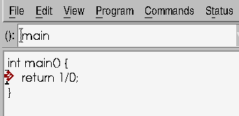

Stack Overflow:

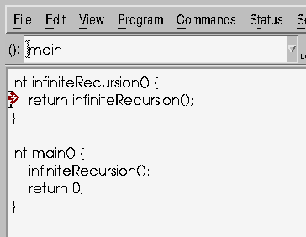

Undefined Memory:

תרגיל 2:

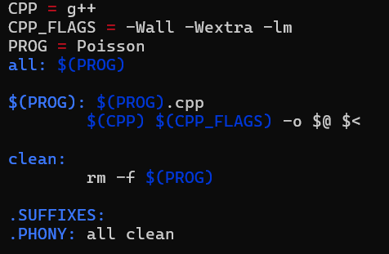

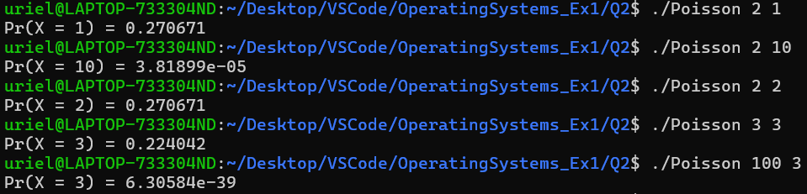

תרגיל 3:

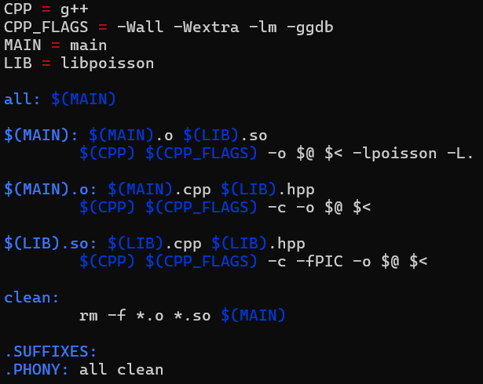

תרגיל 4: